ORGANIZATION OVERVIEW
DOMESTIC ALLIANCE is the charity arm of the Celestial Church of Christ, House of Praise Parish, Manchester. The charity concept is focused on providing support to individuals who are exposed to socially-related vulnerabilities. Such vulnerabilities include: poverty, social exclusion, domestic abuse, and other challenges relating to experiencing social incapacitation in any shape or form. The support activities the charity provides include: sign-posting service-users to organizations where they can get professionally-tailored help, making micro-advocacy on behalf of service-users, conducting community impact engagement programmes within the local community, promoting the Big-Society agenda through communication and outreach channels, and supplying food palliatives and domestic relief materials to service-users.

CONCISE COMMUNIY IMPACT REPORT DURING THE COVID-19 SEASON
DOMESTIC ALLIANCE has been consistently active in providing concerted support for individuals and families since the Covid-19 pandemic began till the present moment. Figures of beneficiaries (on individual basis) presented in this report are aggregated for every 3-month-interval since the pandemic started, and the average for every interval is presented.
June 20 - Aug. 20 | Sept. 20 - Nov. 20 | Dec. 20 - Feb. 21 | Mar. 21 - May 21 | June 21 - Aug. 21 | Sept. 21 - Nov. 21 | Dec. 21 - Feb. 22
50 | 76 | 80 | 80 | 145 | 150 | 146
60 | 58 | 96 | 164 | 246 | 288 | 295

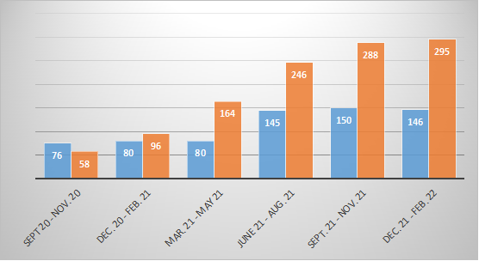

CONCLUSION
So far, the DOMOSTIC ALLIANCE initiative have produced a measurable degree of positive outcomes, However, the Church is committed to looking for innovative ways to improve the structure and modalities with which we operate the initiative. We constantly hope to secure funds and external support, in order to develop more programmes and improve the capacity of the initiative, with a view to making it sustainable and productive with more social outcomes.

